 Project Report Template

TITLE : RECRUITING ASSISTANT FOR HR MANAGER

1. **INTRODUCTION** 
   1. Overview;

In this project, we use custom objects, relationships, page layouts to give the HR team easy

access to data they need on an existing recruitment app.

To make the existing app more efficient for the HR team we create custom objects and

relationships to store and access the data more efficiently. We install an unmanaged package in

the org to get metadata that acts as existing data in the recruitment app.

* 1. Purpose

Human Resource report/HR Report is a way to showcase and analyze all your human resources related metrics, stats, and numbers in the best way possible. Human Resources Reports help to identify areas of improvement and understand different HR functions like employee performance, retention, hiring strategies, and so on.

**2 Problem Definition & Design Thinking**

2.1 Empathy Map

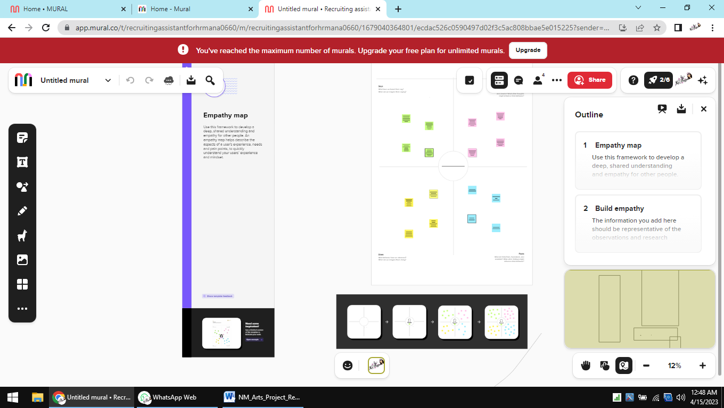

2.2 Ideation & Brainstorming Map

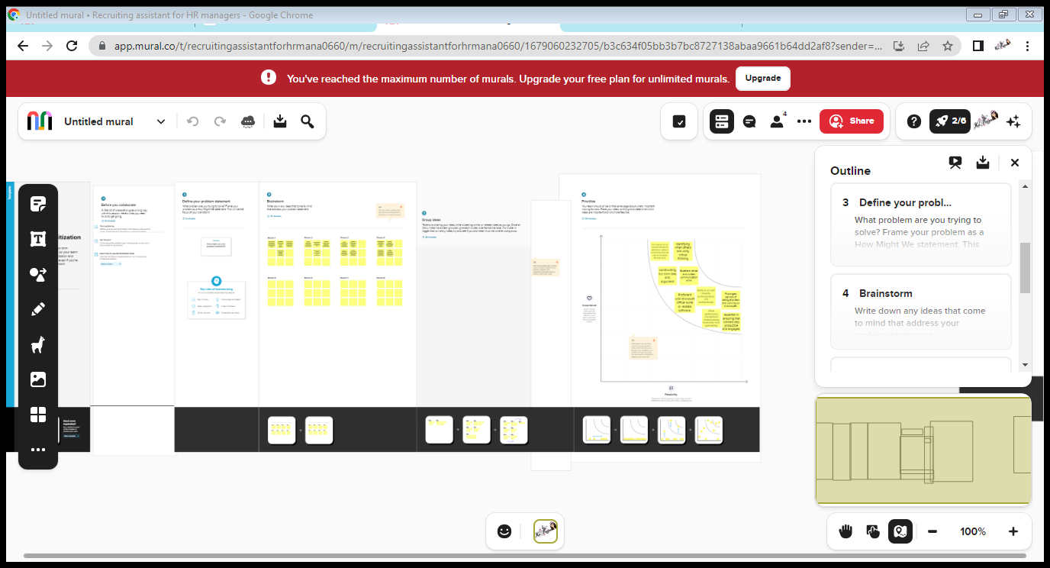

1. **RESULT**

* 1. Data Model:

|  |  |
| --- | --- |
| **Object name** | **Fields in the Object** |
| Custom object | |  |  | | --- | --- | | Field label | Data type | | Job posting site | text | |
| Custom object | |  |  | | --- | --- | | Field label | Data type | | Job position | Auto number | |  |  | |

* 1. **Activity & Screenshot**

Milestone 1: Creation of developer account

Create your Salesforce Developer Org to get Started

In order to start with this project you need to have a free salesforce developer account.

Activity-1

A Developer org has all the features and licenses you need to get started with Salesforce.

1. Search Developer.salesforce.com

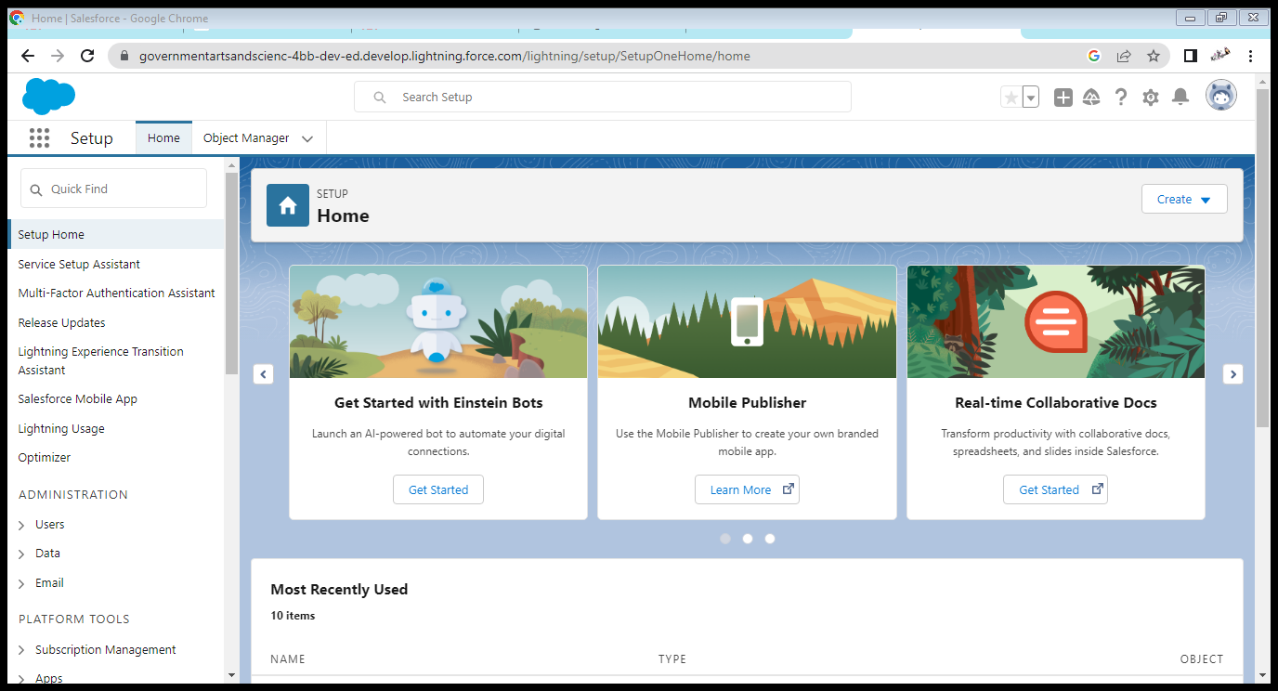

Milestone 2 : Package installation

Package installation for Recruiting App

In Salesforce, a package is a collection of Apex classes, triggers, Visualforce pages, and other

components that can be installed into an organization. There are two types of packages: managed

and unmanaged. Managed packages are developed and distributed by ISVs (Independent

Software Vendors) and can be installed from the Salesforce AppExchange, while unmanaged

packages are created and distributed by Salesforce administrators within an organization. To

install a package, an administrator can navigate to the AppExchange, find the desired package,

and click the "Install" button. The administrator will then be prompted to log in to their

Salesforce organization and provide permission to install the package

.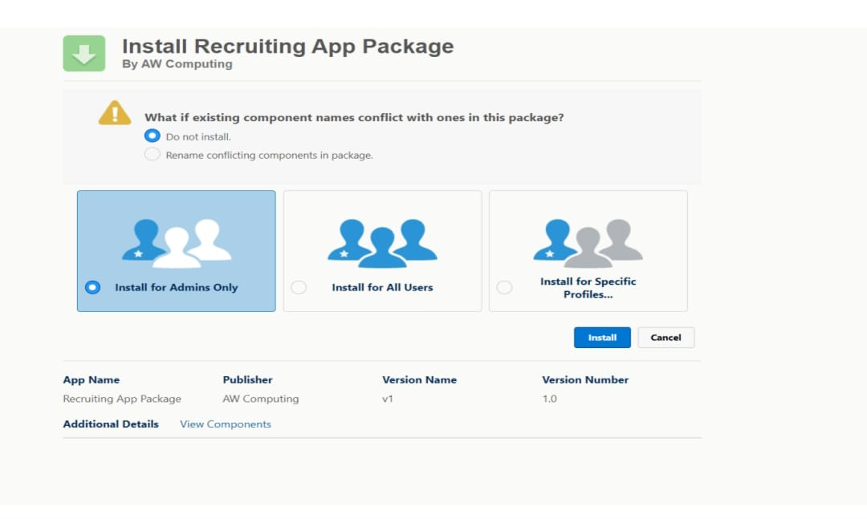

Milestone 3: Object

objects are database tables that permit you to store data that is specific to an

organization.

Create a custom object for Job Posting Sites

To create a custom object, follow these steps :

1. From setup click on object manager.

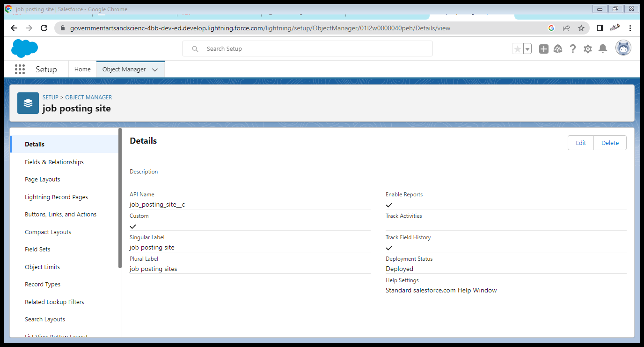

Milestone 4 : Tabs

In Salesforce, a tab is a user interface element that allows users to navigate to different sections

of the platform, such as Accounts, Contacts, Leads, and Opportunities. Tabs can also be used to

access custom objects and custom pages. They are typically located at the top of the screen and

can be customized to fit the needs of the organization.

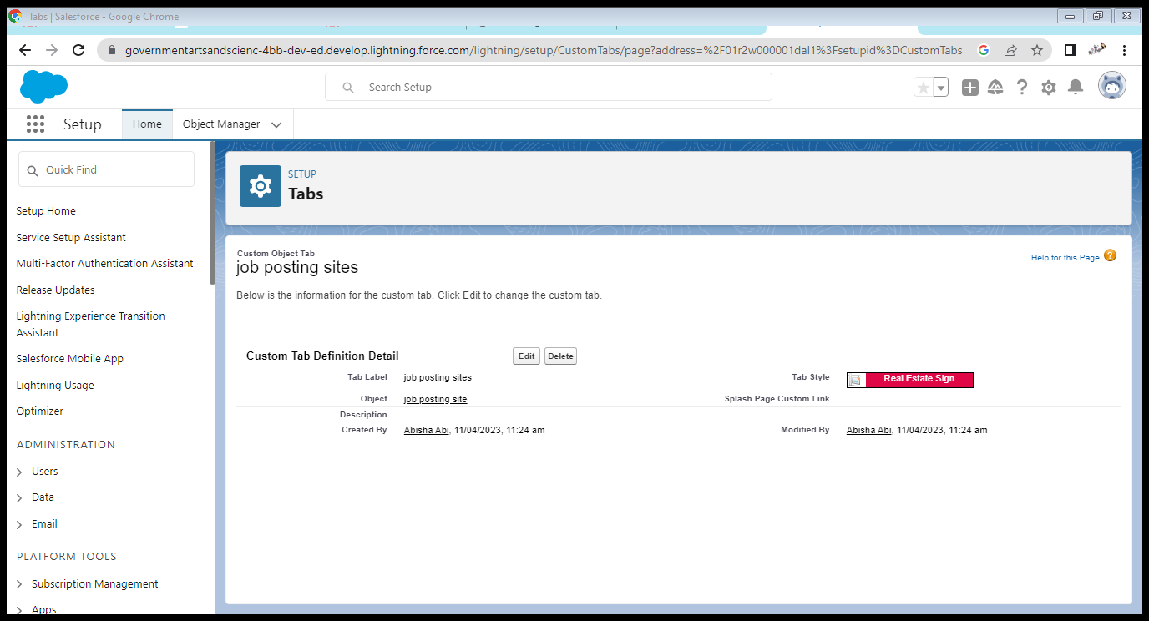

Milestone 5 : Fields

Fields in Salesforce represents what the columns represent in relational databases. It can store

data values which are required for a particular object in a record.

There are 2 types of fields in salesforce:

● Standard fields: There are four standard fields in every custom object that are Created By,

Last Modified By, Owner, and the field created at the time of the creation of an object.

These fields cannot be deleted or edited and they are always required. For standard

objects, the fields which are present by default in them and cannot be deleted from

standard objects are standard fields.

● Custom fields: The Custom fields which are added by the administrator/developer to

meet the business requirements of any organization. They may or may not be required.

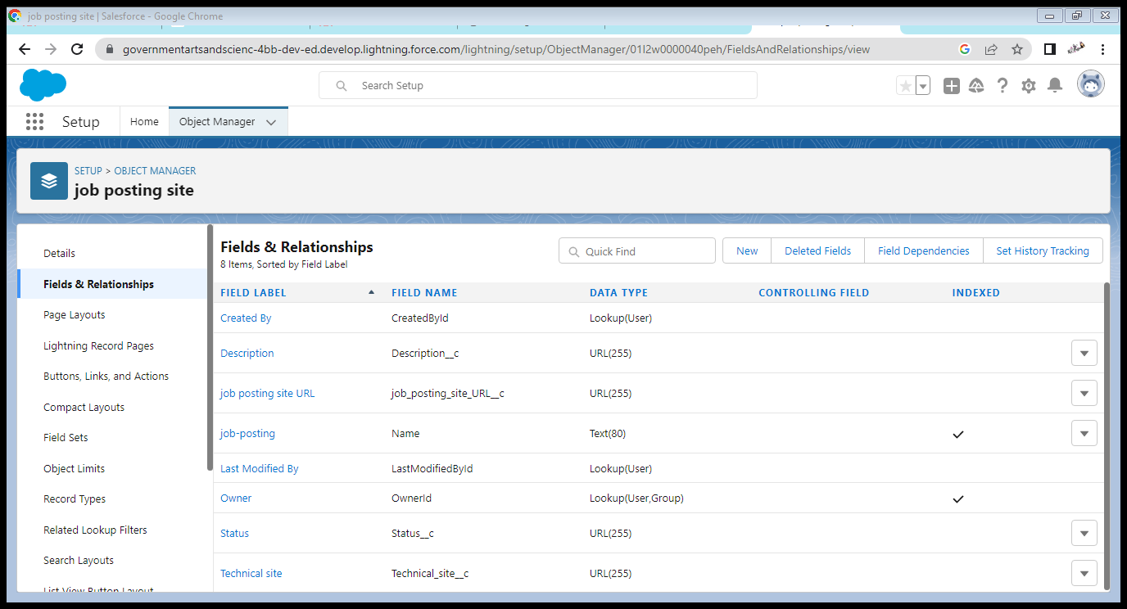

Milestone 6 : Junction Object

In Salesforce, a junction object is a custom object that is used to create a many-to-many

relationship between two other objects. It connects two objects together by creating two

one-to-many relationships, allowing data from both objects to be associated with each other in a

single record. For example, if you have a custom object for "Projects" and another for "Teams," a

junction object could be used to connect individual team members to multiple projects.

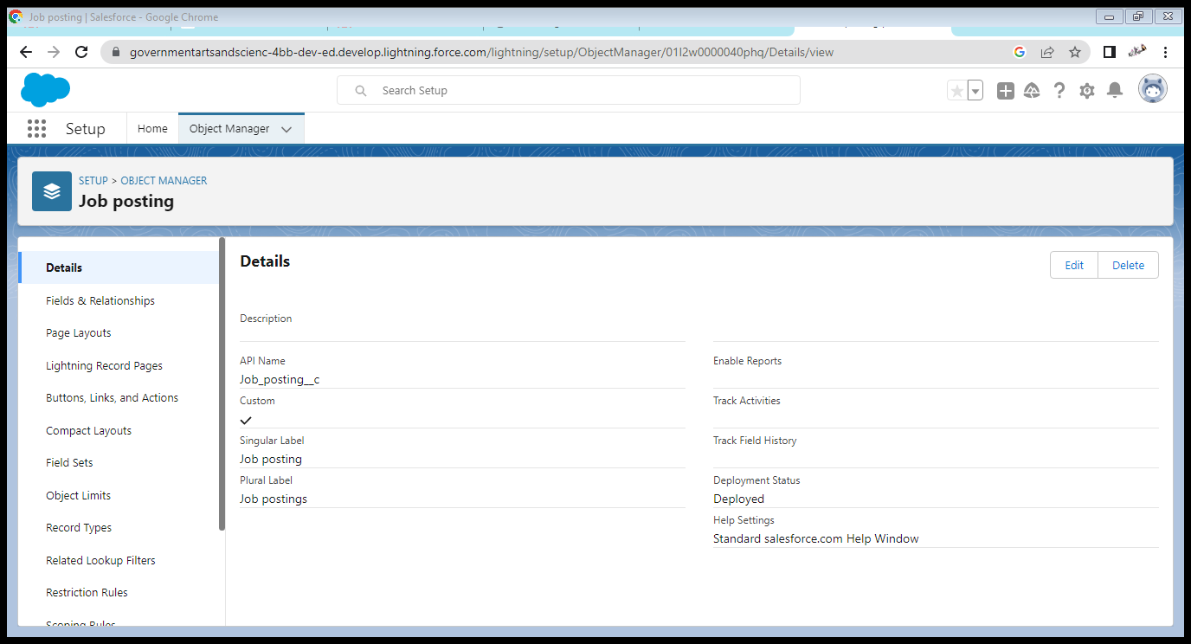

Milestone 7: Page Layout

In Salesforce, a page layout is a visual design of a page that determines the organization and

arrangement of fields, buttons, and other components on a page. Page layouts can be customized

to show the fields and related information that are most relevant to different users, roles, and

record types. They can also be used to control the visibility and access to fields, buttons, and

other components on a page.

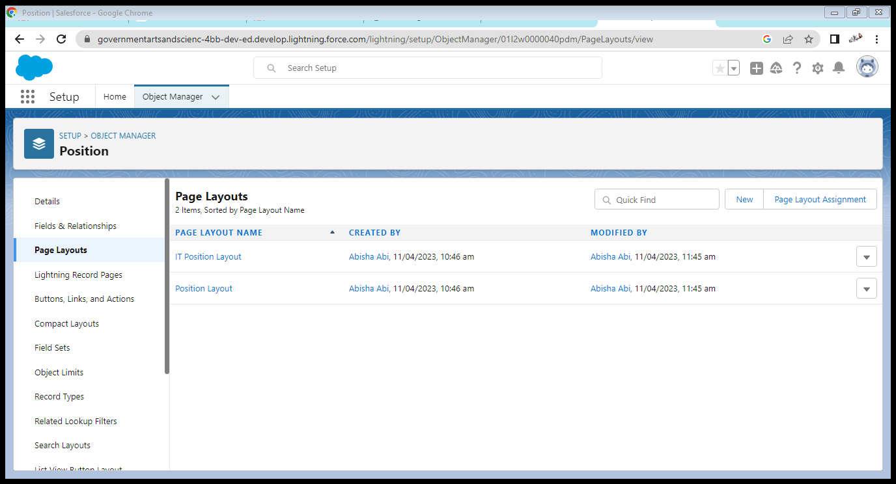

Milestone 8 : Validation Rules

A validation rule is a process which checks out (validate) the inputs given by any user is correct

or not according to your requirement.

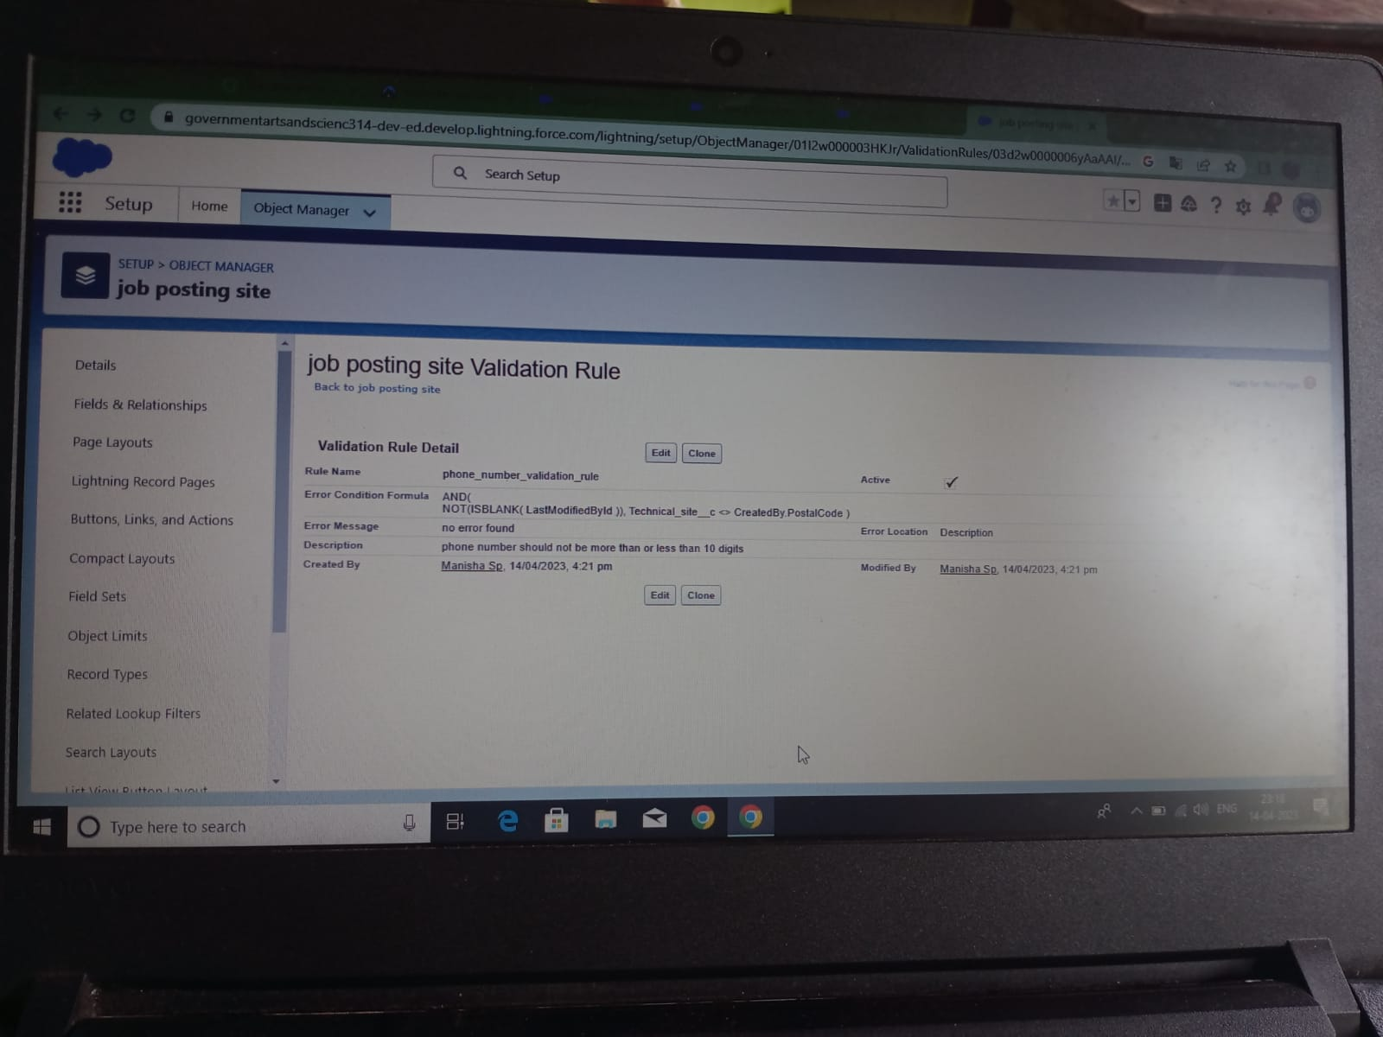Milestone 9 : Profile

A profile is a group/collection of settings and permissions that define what a user can do in

salesforce. A profile controls “Object permissions, Field permissions, User permissions, Tab

settings, App settings, Apex class access, Visualforce page access, Page layouts, Record Types,

Login hours & Login IP ranges.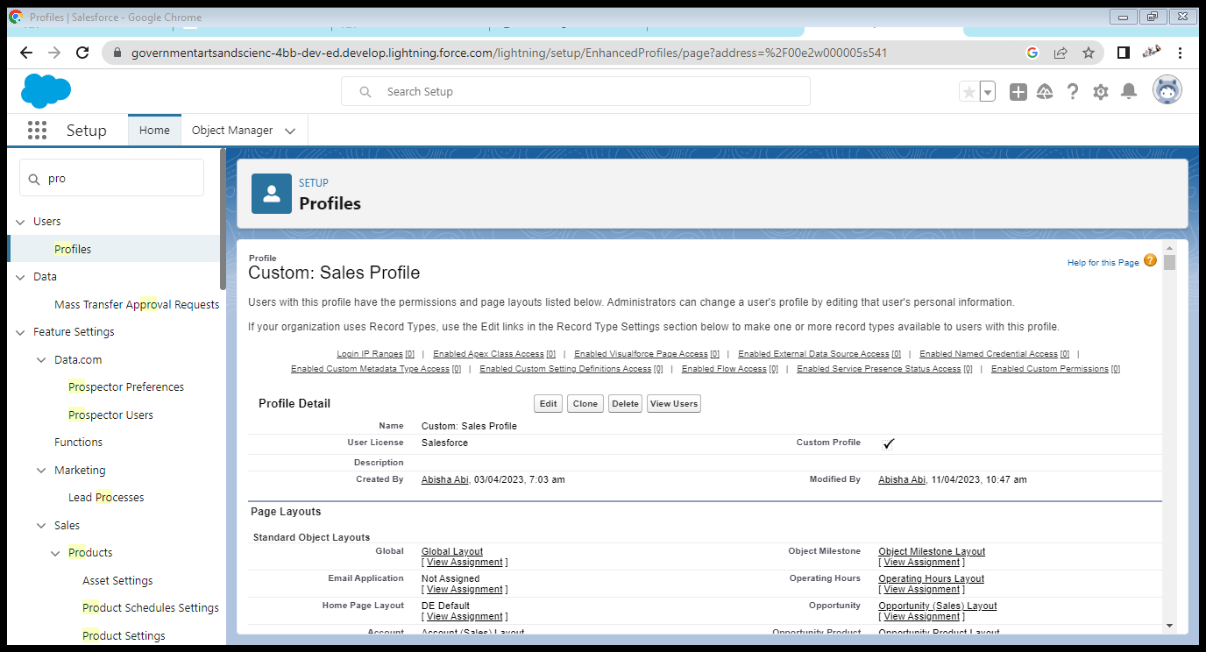

Milestone 10: User

A user is anyone who logs in to Salesforce. Users are employees at your company, such as sales

reps, managers, and IT specialists, who need access to the company's records. Every user in

Salesforce has a user account. The user account identifies the user, and the user account settings

determine what features and records the user can access.

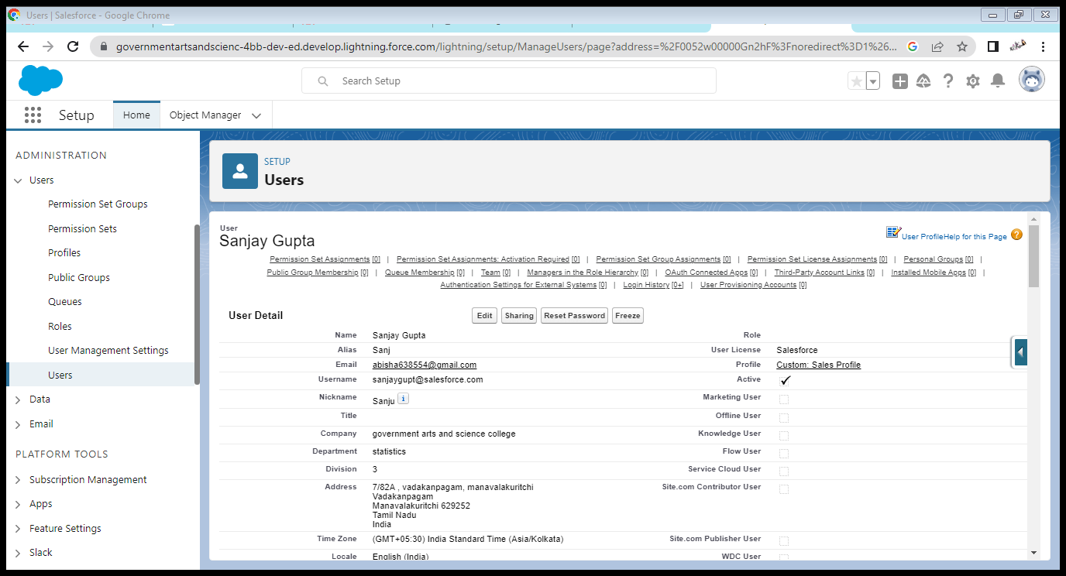

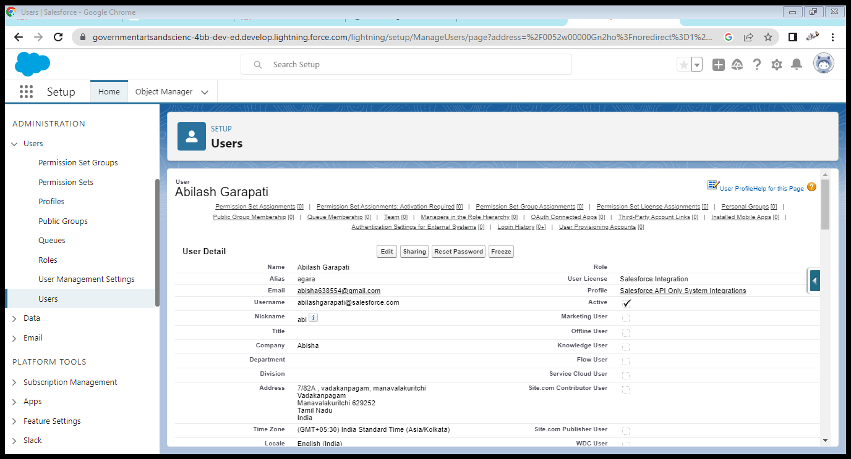Milestone 11 : Permission sets

In Salesforce, a permission set is a collection of settings and permissions that give users access

to various tools and functionality in the platform. Permission sets can be used to grant

additional access to users beyond what is included in their profile, without modifying the

profile itself. This allows for granular control over user access and permissions within the

Salesforce environment. Permission sets can be assigned to individual users or to a group of

users.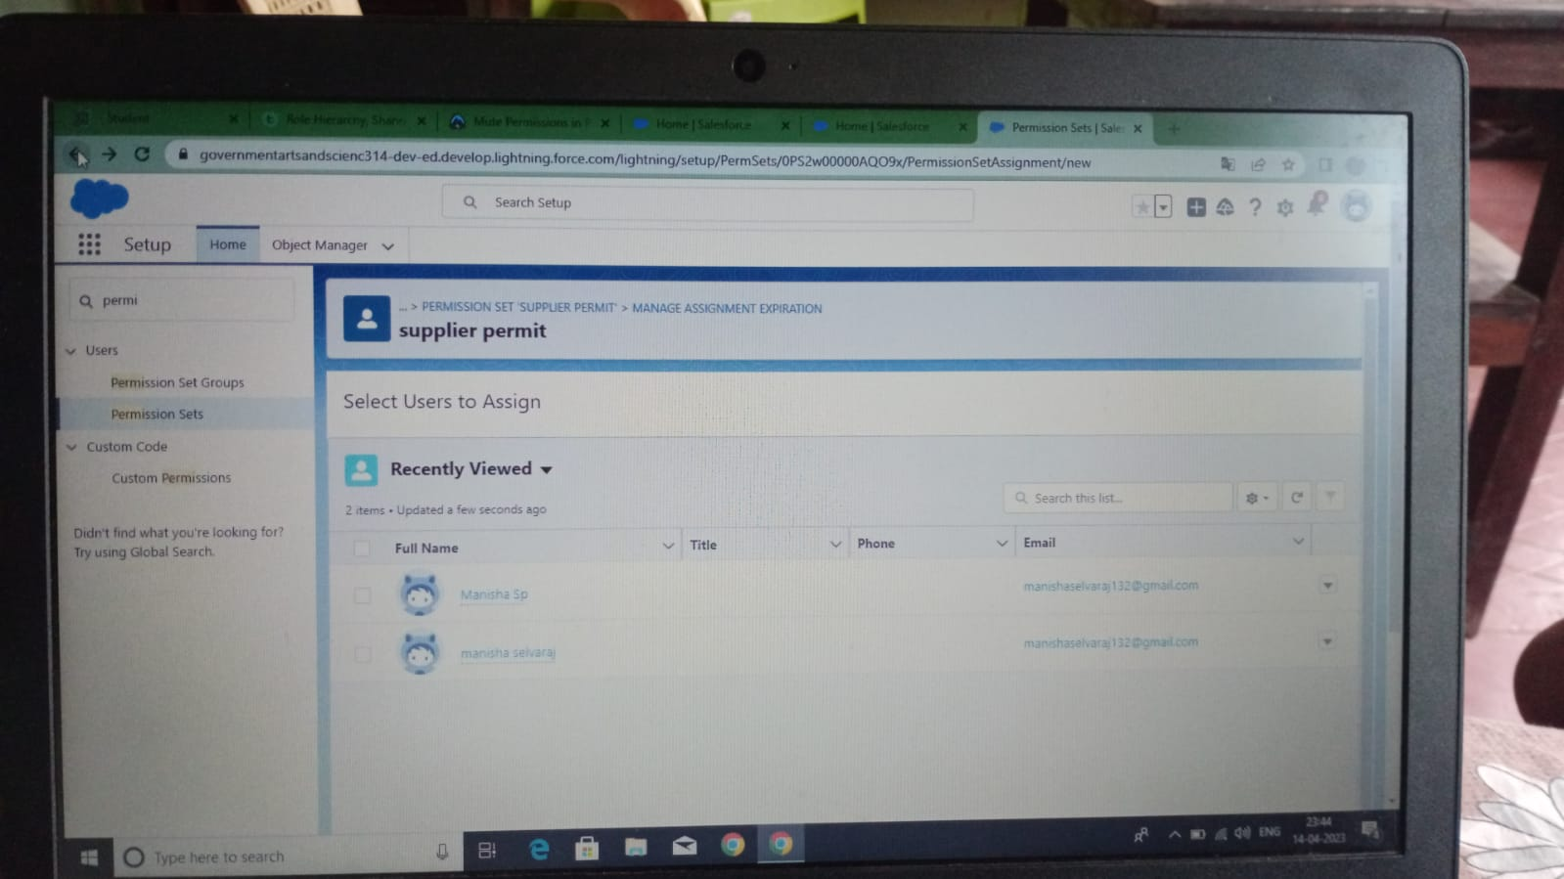

Milestone 12: Report

A report is a list of records that meet the criteria you define. It's displayed in rows and columns, and can be filtered, grouped, or displayed in a graphical chart. Every report is stored

in a folder. Folders can be public, hidden, or shared, and can be set to read-only or read/write.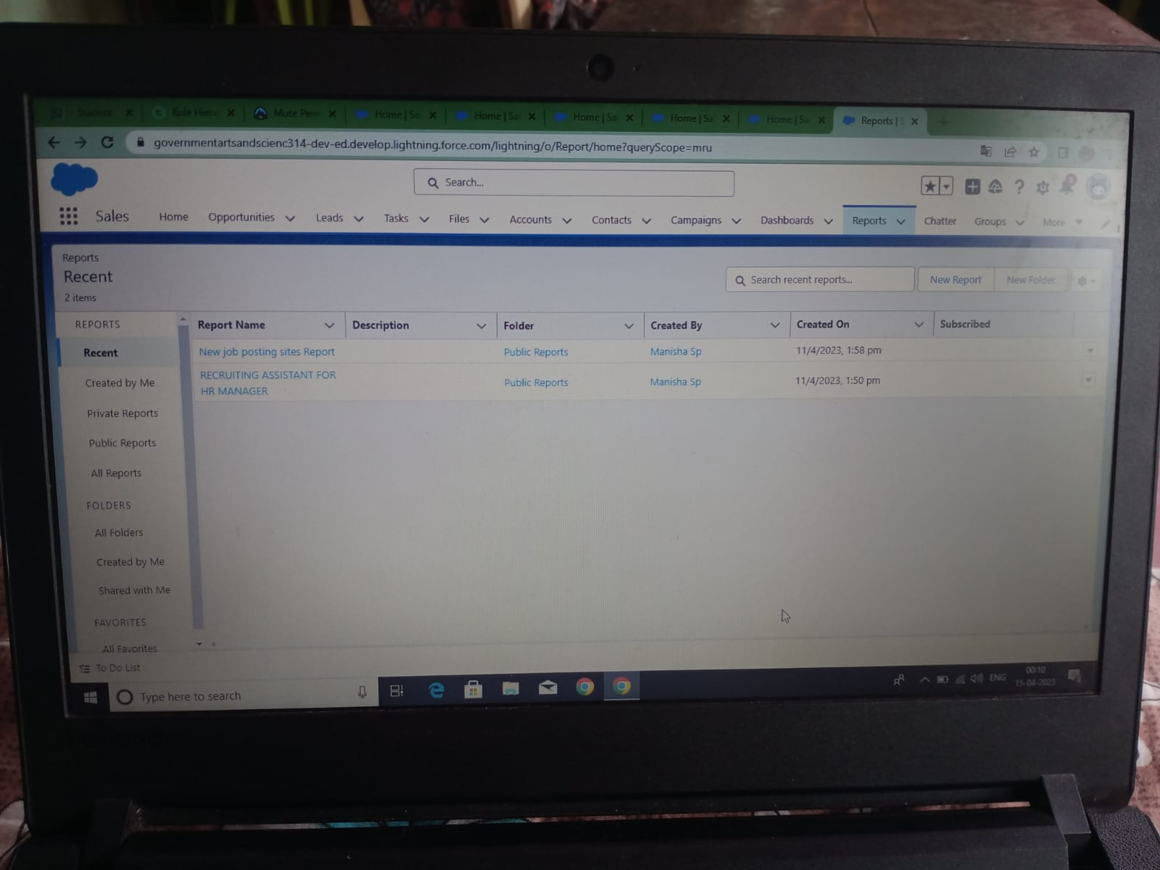

1. **Trailhead Profile Public URL**

**Team Lead -**<https://trailblazer.me/id/abisha5>

**Team Member 1 -** <https://trailblazer.me/id/athulkb>

**Team Member 2 -** <https://trailblazer.me/id/manishasp>

**Team Member 3 –** <https://trailblazer.me/id/vijishavj>

1. **ADVANTAGES & DISADVANTAGE**

ADVANTAGES

Integrating payroll is a cost-effective way to ensure that employees have access to payroll documents, such as withholding forms and direct deposit information. It also offers a portal so employees can retrieve pay stubs and tax forms rather than a human resources clerk having to produce, distribute and send to an employee.

DISADVANTAGE

As with any new technology, there is a cost to license and implement a new system. Costs range, and they depend on the capabilities of the HRIS system, but they may be as high as $300 per employee for large companies with many benefits capabilities. Smaller companies should expect to pay anywhere from $40 to $100, and that doesn't include payroll processor costs.

1. **APPLICATIONS**

HRIS (human resources information system) is a type of business application that enables companies to store employee information, manage common HR functions, and execute critical HR activities such as processing payroll and administering benefits.Features of HRIS applications include an employee self-service portal, payroll, workforce management, recruitment and hiring, benefits administration, and talent management. These capabilities are often delivered through individual modules that form a unified suite of HR tools

1. **CONCLUSION**

Role of HR is changing with time. There has been an increase in Knowledge work. Managers spend most of their time in analysis, decision making and communication. Considering that, following things would become important for managers of DSOs in future:Managing cultural diversity, satisfying individual learning needs, managing employee turnover, moulding employees in short time, synchronizing skills of different people in one project, reducing adjustment time of employees and Developing Leadership skills among managers.

1. **FUTURE SCOPE**

The future of Recruiting departments will need to upskill, track new metrics, and adopt new technologies. They will need to take on a more visible, strategic role within the business and will seriously rethink the way they see their job. So, take a step back and look at how the future of recruitment process is going to shape out and the effects it's going to have.